Press release

Aluminium frame glass door element A85

Karlsruhe, January 2021. At BAU Online 2021, the feco Group will present an aluminium frame door flush on the corridor side with a sound insulation test value of R _{w,P} = 42 dB. The 85-mm-thick door leaf is rebated on the hinge side and flush with the door frame on the opposite side. The frame can be concealed on the corridor side.

The door leaf frame made of extruded aluminium profiles is mitred at all four corners and connected with 3D press angles. 120-mm-high, 3D-adjustable commercial triple-roll hinges with angular hinge straps and the tubular frame mortise lock with a whisper trap are flush with the system groove on the front. The use of commercially-available cranked tubular frame object handles is possible in aluminium and stainless steel. The frame face width of the door leaf is 75/105 mm. The double glazing allows for the optional use of 25-mm-wide horizontal slats. These can be mounted axially in the centre of the inter-pane space. The interior blinds can be operated either with a rotary knob or electrically with a concealed cable transition.

The door element fulfils the sound insulation recommendations for rooms used for concentrated mental activities and confidential discussions according to DIN 4109, Supplement 2 whilst having the same appearance as the fecotür A70 on the corridor side. It thus supplements the feco partition wall system with a helpful tool for creating sustainable office work environments.

See www.feco.de.

The feco Group creates spatial solutions that connect and inspire people.

feco Systeme GmbH
feco Systeme GmbH develops space-defining partition wall systems for high design and construction-related requirements. The company sells system components to licensed partners worldwide. Commercial-property carpenters and large interior design companies create the system partition walls according to their respective country-specific requirements. As the licensor, feco provides partners with access to a sophisticated wall system. This includes upright, glass-frame and connecting profiles, as well as static, sound and fire prevention test certificates. As a result, a large number of solid and glass wall systems are available, and these are used in the buildings of high-profile customers. The design possibilities range from solid walls with veneer or melamine surfaces, to single-pane or double-glazing glass walls.

feco-feederle GmbH
feco-feederle GmbH creates challenging projects realised with feco system partition walls and strong brand office furnishings. Thanks to its two divisions, the company is able to offer a complete spatial design service for office buildings, research and educational institutions from a single source that encompasses the project-oriented design, manufacture and installation of feco system partition walls and interior design services, as well as the design, planning and realisation of office furnishings with high-quality brands.

feco Systeme GmbH and feco-feederle GmbH are sister companies with the same shareholders.

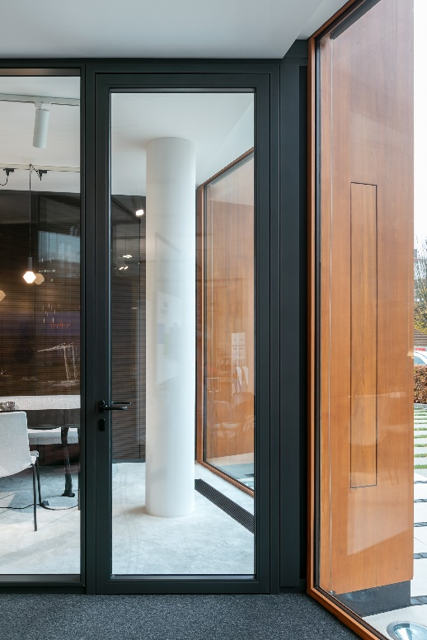

File name: NK_20_3960.jpg
Caption: fecotür A85 – sound insulation for concentrated work

Photographer: Nikolay Kazakov, Karlsruhe
nikolay@kazakov.de, www.niko-design.de

The photographer, Nikolay Kazakov, is to be named directly beneath the image or at another suitable location.

All rights of use are held.

Reproduction free of charge / copy requested

Additional information for journalists:
feco Systeme GmbH PR-Agentur blödorn pr
Rainer Höhne Heike Blödorn
Am Storrenacker 22 Alte Weingartener Str. 44
76139 Karlsruhe 76227 Karlsruhe
Phone 0721 / 62 89-111 Phone 0721 / 9 20 46 40
E-mail: info@feco.de E-mail: bloedorn@bloedorn-pr.de

